# Technical proposal CDS-M

## Requirements

Framework that describes data exchange between city and mobility provider (initially).

## Break up

The framework should describe the data exchange’s next dimensions:

* Reason
  + Use case
  + Benefits
  + Problems solved
* Contractual aspects
  + Terms and conditions
  + Contracts and their parameters
* Technical aspects:
  + Used standards
    - Exceptions
  + Requirements to
    - Collection of data
    - Processing of data
    - Storage of data
* Legal aspects
  + Sharing aspects
* Contextual aspects
  + Allowed combinations of use cases
* Evaluation
  + Ethical aspects
  + Security
  + Interoperability

## Three levels

We distinguish 4 levels in this framework:

* the specification, consisting of use cases and their building blocks
* the use cases that are specified using the specification
* a city’s selection
* an implementation between a city and a mobility provider

Level 1: The specification will be public available (Github).

Level 2: The use cases that are specified & verified, public available on Github as well.

Level 3: Cities can specify, using the use cases what data they need and how it must be implemented. On the other hand, mobility providers can specify how they default deliver the data using the use cases (or refer simply to the building blocks).

Level 4: a city and a mobility provider agree on how the data will be exchanged, the specification will be set up accordingly and must be solidified (on the blockchain?)

## Implementation

In Github, there will be a collection of building blocks, each dimension above refers in Github to a folder, containing building blocks, for example in the contract folder, you will find a DPIA template and the fields inside that have to be filled in to complete a DPIA.

Secondly, on Github the verified use cases must be stored, constructed using the building blocks above. It is possible to have multiple choices in one dimension (e.g. in the standards, operating areas can be exchanged using GBFS, GTFS, NeTEx and TOMP-API). Cities can use these use cases, eventually limit the choices and expose this as their required data exchange specification.

These city side specification should only contain building blocks that are agreed on and stored in the Github repository.

* CDS-M Github
* Use case folder
* Use case 1
* Use case 2
* …
* Building blocks folders:
* Terms and conditions
* Contract parts
* Standard parts
* Sharing options
* Certifications
* Encryption
* Authentication
* Storage terms
* Legal requirements
* Aggregation levels

Question is whether to store the city level (level 3) specification should be on Github as well. Level 4 (agreement city-mobility provider) shouldn’t be on Github.

## Validation

As we see it, the use cases (level 2), city implementations (level 3) and the agreements (level 4) can be measured against a few guidelines:

1. Ethical : Tada makes it possible to validate them on ethical dimensions. Therefore each building block can be annotated with consequences on each Tada dimension.
2. Interoperability: look if “Mobility Data Interoperability Principles” can be used for this. Otherwise, we have to look for another one
3. Security: we could have a look at OWASP, to find out whether some things in there can be used.

## Specification tooling

Based on use cases and building blocks in Github, there must be a viewing tool, reading the data from Github, giving a clear overview of the use cases and validate them directly.

When a city wants to specify their use cases and make a specification, it shouldn’t be any harder than checking boxes, and see the impact on the validation.

Finally, the city can export the specification they need (where to store?)

Agreements (level 4) between a city and a mobility provider can be specified as well in this tool, making it possible to export the level 4 specification, also delivering a hash to make it possible to store it on the blockchain.

## Governance

### Acceptance

New building blocks should be accredited before they are added to the github repository. (process already described). <Process description should be incorporated here>.

### Roles

<Required roles in this process>

Some documents we can look into:

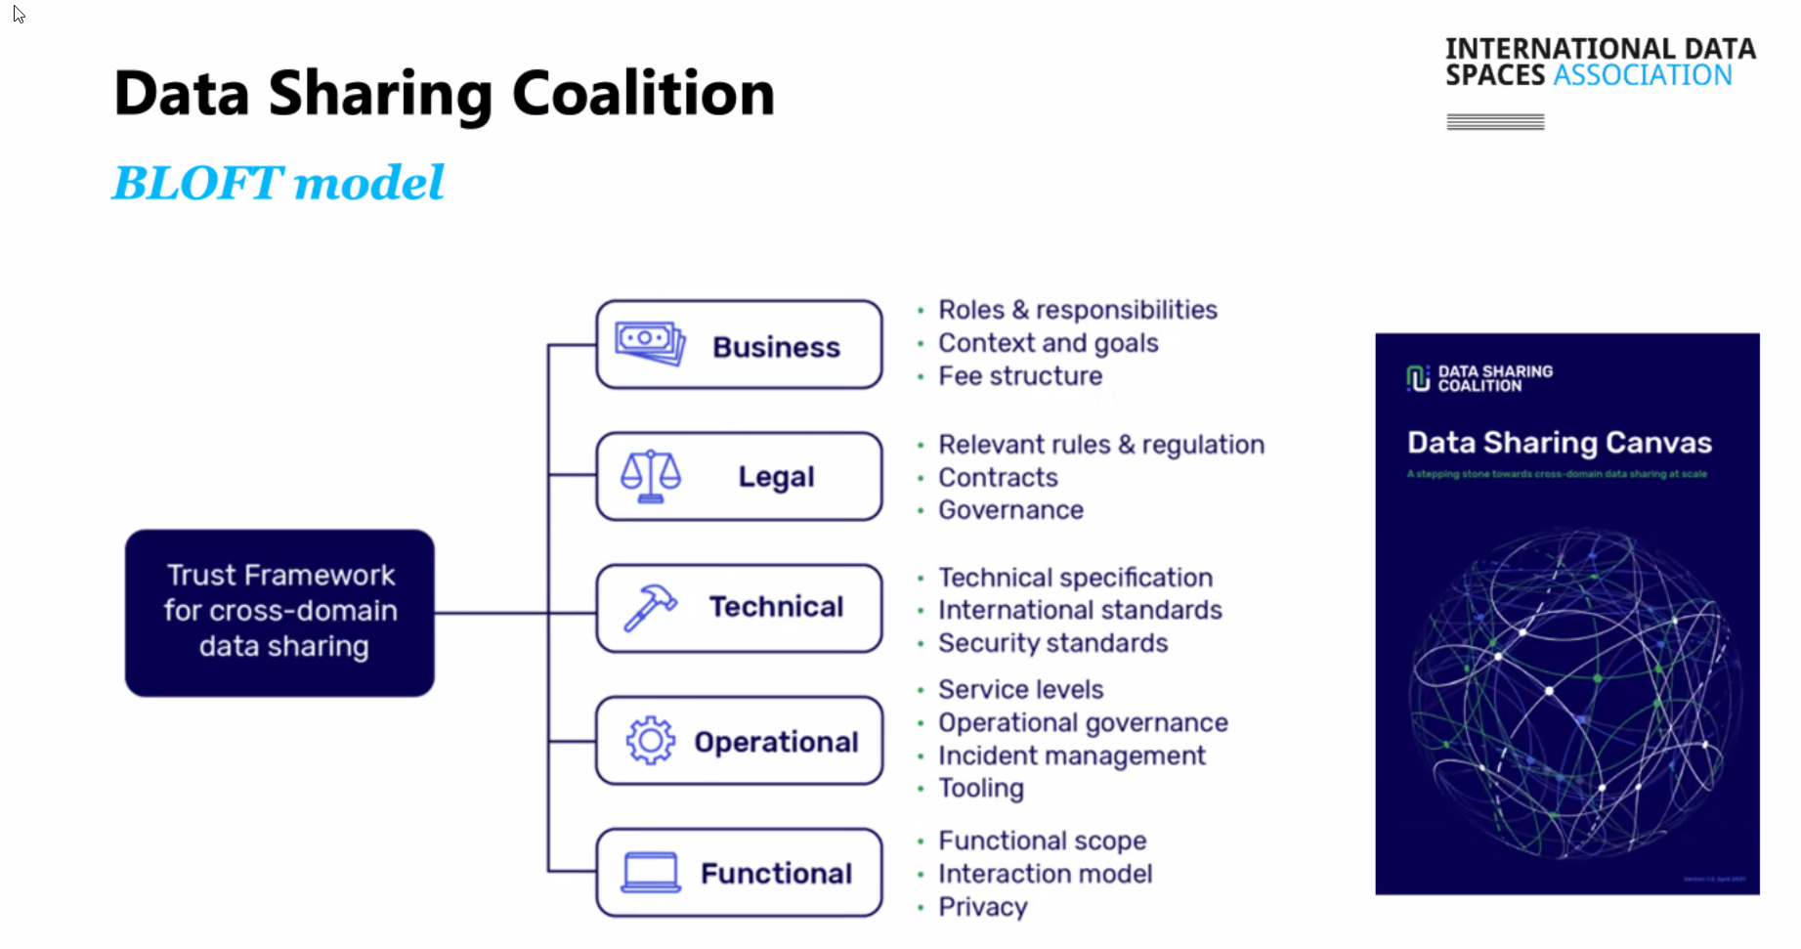

https://www.sitra.fi/en/publications/rulebook-for-a-fair-data-economy/